Brian Christopher T. Guadalupe
II – Diocese of Kabankalan
Activity: Mini-Symposium (Gender Sensitivity)
Date/Venue: Monday, November 26, 2012 at the Classroom

I. Significant Experiences
On this day, the whole Homeroom period was allotted for our mini-symposium. The speaker was Mr. Conrado Quijano. The mini-symposium was about gender sensitivity. He talked about the definition of gender sensitivity and how can it be a big problem especially to the corporate world. First, the speaker showed us a video clip about how men and women differ in many things. From there, he asked us the following questions: 1) Kindly specify situations that have happened within the class that is similar to the video clip? 2) Are you having a difficult time in dealing with your classmates who happens to be in the opposite gender? And 3) Do you feel that there is inequality within class in terms of opportunity in advancement? Then he proceeded to talk about gender inequality and how it can be a problem in work and in school, after which he listed some occupations and asked two students to write on the board if the occupation was done by men, women, or both. He said that all of the occupations listed are all done by either gender. The speaker also discussed on how gender equality can be achieved and maintained, may it be in work, or in school, also the proper manners in dealing with the opposite gender. From there, the discussion finally came into a close. Like the previous mini-symposium, a certificate and a token of appreciation was given to the speaker.
II. Significant Learning
I learned that gender sensitivity teaches people how to deal properly with people from the opposite gender. Both genders should have equal rights and privileges to anything they might encounter on.

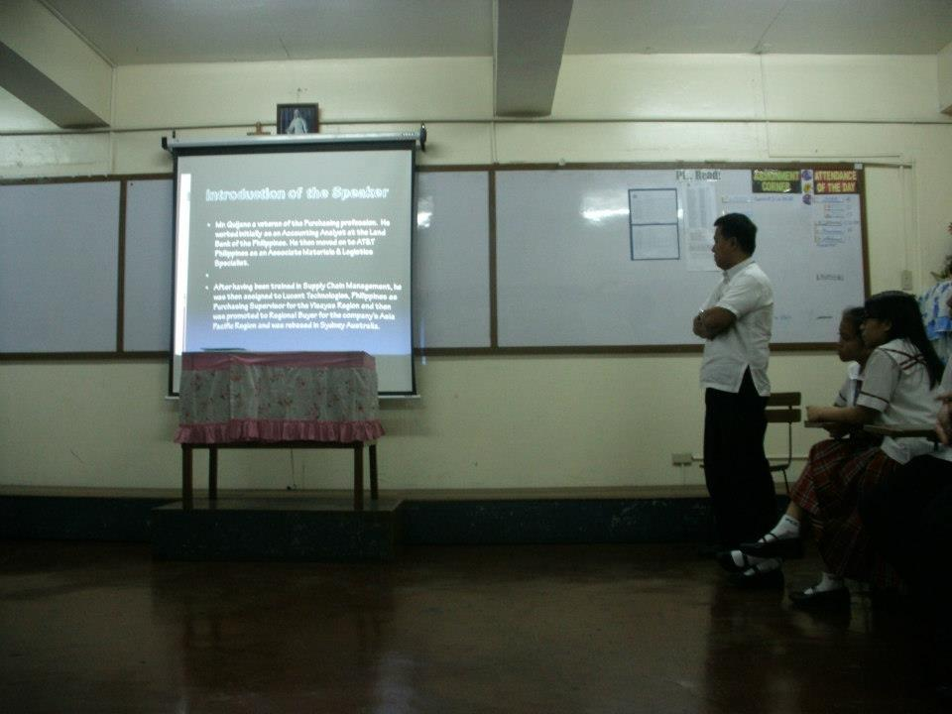
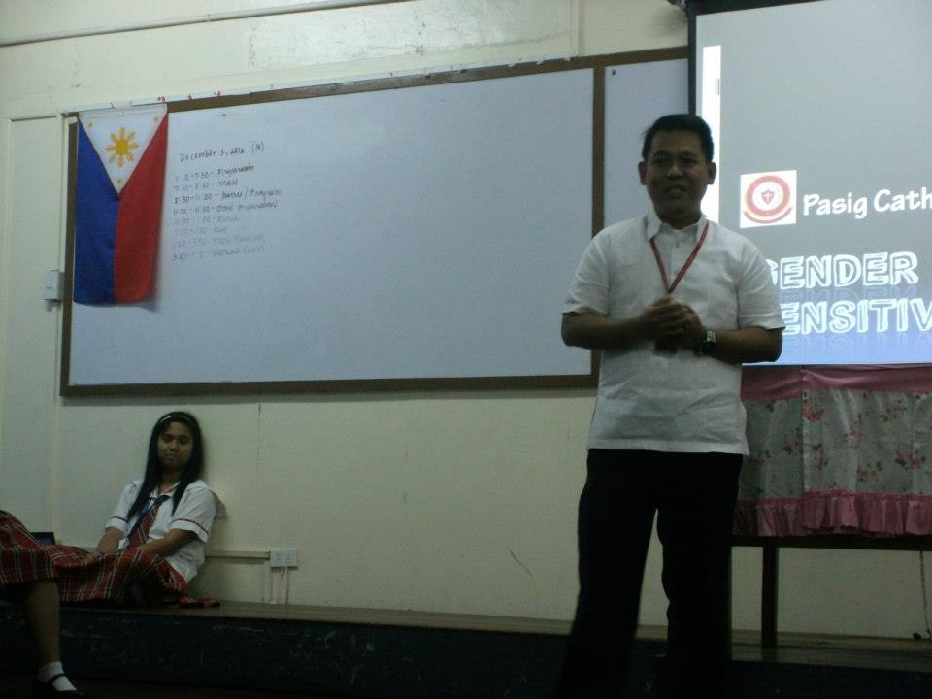
III. Pictures
